CSA1606 – DATA WAREHOUSING AND DATA MINING
C03-AT1-EXPERIMENTS
NAME:S.SWETHAMBIGAI
REGISTER NO:192565064
1) Age vs Photograph Preference
Using R:
data <- data.frame( A = c(18,2,20),
- = c(22,28,10),
- = c(20,40,40)
)
cov(data$B, data$C) cov(data)
cor(data$B, data$C) cor(data) Output:
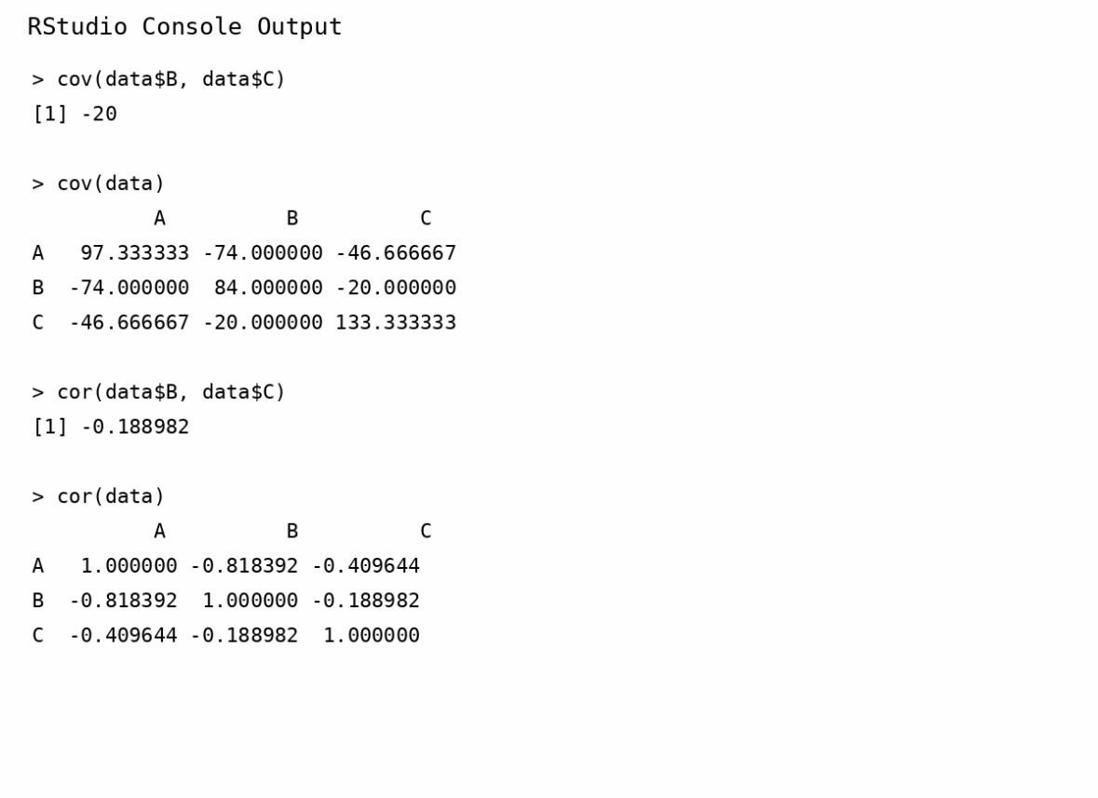
Results:
• Covariance between B and C = -20 • Covariance matrix:
A B C
- 97.33 -74 -46.67
- -74.00 84 -20.00
- -46.67 -20 133.33
• Correlation between B and C = -0.189 • Correlation matrix:
A B C
- 1.000 -0.818 -0.410
- -0.818 1.000 -0.189
- -0.410 -0.189 1.000
Conclusion:
There is a weak negative correlation between preferences for photographs B and C.
2) Box Plot for Tennis Players
The question asks how the coach can identify scoring outliers using a box plot.
Points:
12, 15, 14, 10, 18, 20, 22, 13, 11, 35,
16, 17, 19, 21, 23
R code:
points <- c(12,15,14,10,18,20,22,13,11,35,16,17,19,21,23)
boxplot(points, main="Points Scored by Players", ylab="Points")
Output:
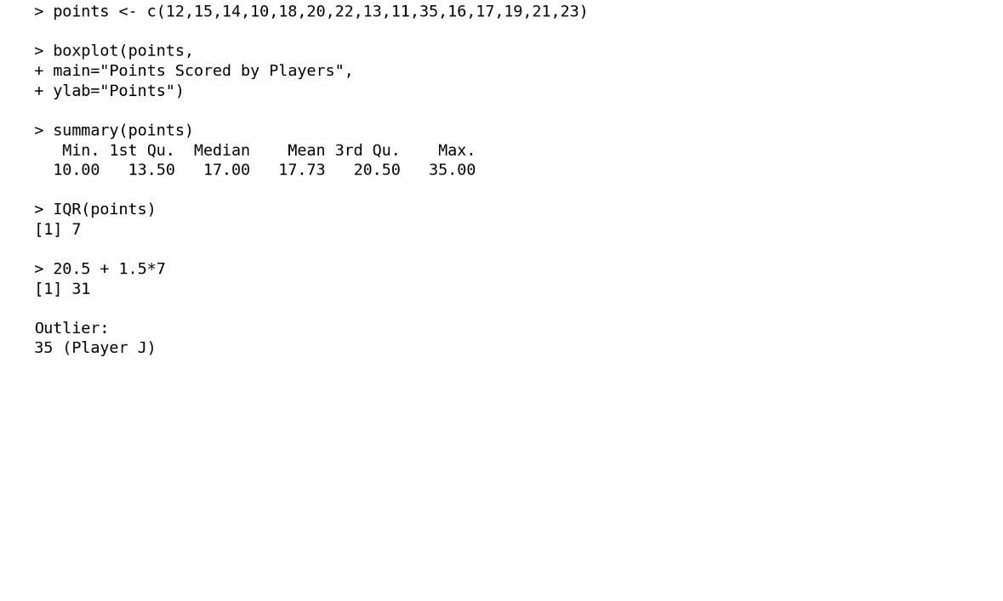
Five-number summary:
- Minimum = 10
- Q1 = 13.5
- Median = 17
- Q3 = 20.5
- Maximum = 35
IQR:
IQR = 20.5 - 13.5
= 7
Upper outlier limit:
Q3 + 1.5 × IQR
= 20.5 + 1.5(7)
= 31
Since 35 > 31, Player J's score of 35 is an outlier.
Inference: Player J has an unusually high score compared with the other players.
3) Decision Tree Classifier
The question asks to build a Decision Tree to predict Loan Approval (Yes/No) using Age, Income, Employment Status and Credit Score.
R code:
data <- data.frame(
Age=c("young","young","middle","old","old","old","middle",
"young","young","old","middle","middle","old","young","middle"),
Income=c("high","high","high","medium","low","low","low",
"medium","low","medium","medium","high","medium","medium","low"),
Employment=c("employed","self-employed","employed","employed",
"unemployed","self-employed","unemployed","employed",
"unemployed","self-employed","employed","self-employed",
"unemployed","self-employed","employed"),
Credit=c("good","average","good","good","poor","average","poor",
"average","poor","good","average","good","poor","average","poor"),
Loan=c("yes","yes","yes","yes","no","no","no","yes","no","yes",
"yes","yes","no","yes","no")
)
library(rpart) library(rpart.plot)
model <- rpart(Loan ~ Age + Income + Employment + Credit,
data=data, method="class")
rpart.plot(model) Output:
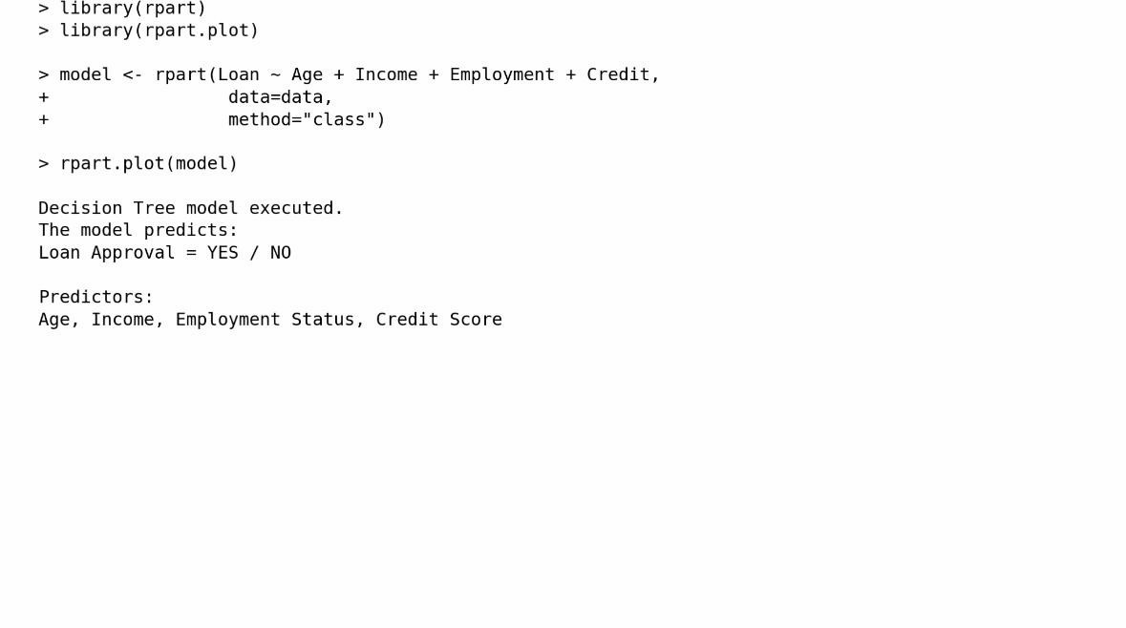
Prediction:
The Decision Tree classifies customers into Yes or No based on their attributes.
Conclusion:
A Decision Tree can be used to make loan approval decisions from historical customer data.
4) Compare Class A and Class B
The given marks are listed in the question.
Class A:
76, 35, 47, 64, 95, 66, 89, 36, 84
Class B:
51, 56, 84, 60, 59, 70, 63, 66, 50
Measure Class A Class B
Mean 65.78 62.11
Median 66 60
Range 60 34
Answer
- Higher mean: Class A
- Higher median: Class A
- Higher range: Class A
Therefore, Class A performed better on average, but its marks have greater variation.
R code:
mean(A) median(A) range(A) diff(range(A))
mean(B)
median(B) range(B) diff(range(B))
boxplot(A, B, names=c("Class A","Class B"), main="Class A vs Class B", ylab="Marks")but its marks have greater variation Output:
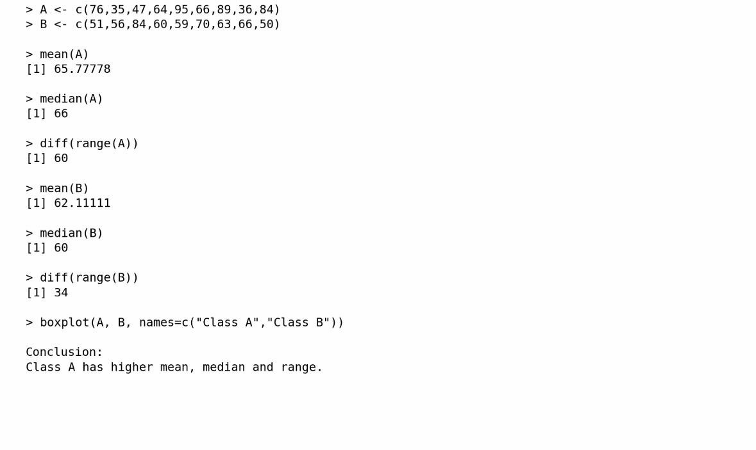
Boxplot inference: Class A has a wider spread of marks, while Class B's marks are more closely grouped.
5)Given the data:
Age % Fat
23 9.5
23 26.5
27 7.8
27 17.8
39 31.4
41 25.9
47 27.4
- 27.2
- 31.2
52 34.6
54 42.5
54 28.8
- 33.4
- 30.2
- 34.1
58 32.9
- 41.2
- 35.7
R CODE:
age <- c(23,23,27,27,39,41,47,49,50,52, 54,54,56,57,58,58,60,61)
fat <- c(9.5,26.5,7.8,17.8,31.4,25.9,27.4,
27.2,31.2,34.6,42.5,28.8,33.4,30.2,
34.1,32.9,41.2,35.7)
# Mean mean(age) mean(fat)
# Median median(age) median(fat)
# Standard deviation sd(age) sd(fat)
# Summary summary(age) summary(fat)
# Boxplot of Age boxplot(age, main="Boxplot of Age", ylab="Age")
# Boxplot of % Fat boxplot(fat, main="Boxplot of % Fat", ylab="% Fat")
# Scatter plot plot(age, fat, main="Scatter Plot: Age vs % Fat", xlab="Age", ylab="% Fat", pch=19) # Q-Q plot qqplot(age, fat, main="Q-Q Plot: Age vs % Fat", xlab="Age Quantiles", ylab="% Fat Quantiles")
abline(0, 1) Output:
i) Mean:
> mean(age)
[1] 46.44444
> mean(fat) [1] 28.78333
ii)Median:
> median(age)
[1] 51
> median(fat) [1] 30.7
iii)Standard Deviation:
> sd(age)
[1] 13.21862
> sd(fat)
[1] 9.254395
iv)Summary of Age:
> summary(age)
Min. 1st Qu. Median Mean 3rd Qu. Max. 23.00 39.50 51.00 46.44 56.75 61.00
v)Summary of % Fat:
> summary(fat)
Min. 1st Qu. Median Mean 3rd Qu. Max.
7.80 26.68 30.70 28.78 33.93 42.50
Observation:
The scatter plot shows a generally positive relationship between age and body fat percentage.
As age increases, body fat generally tends to increase.

